# Lab 2. Task 1- preparation task Template for answers

**Save this document as a .pdf document before submitting.**

*Student names and LiU-IDs: (Max 2 students per group):*

1. *Thomas Indrias (thoin216)*

*Submission date: 02-12-2018*

*Version (in case you need to re-submit): 1.0*

## **Testing different box filters**

**1)** Image1:

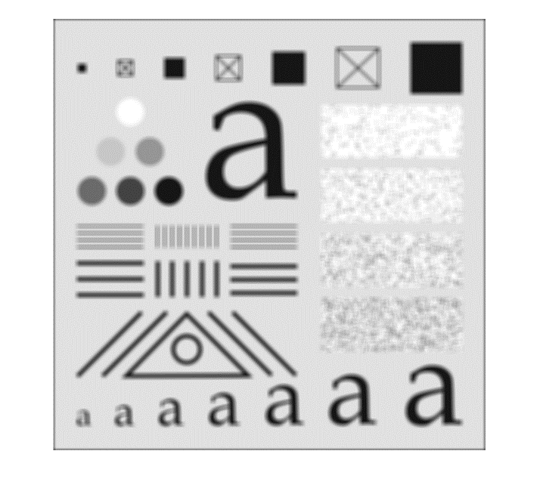

**2)** Image2:

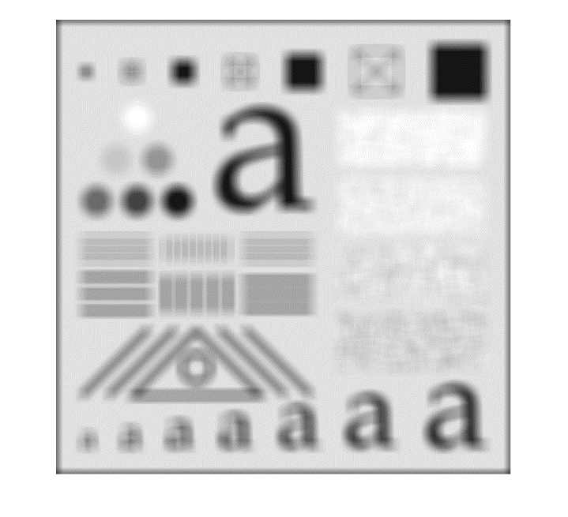

**3)** Does the box filter have a lower or higher cutoff frequency than the box filter? Explain why!

% This means that 21x21 has a lower cutoff frequency because it

% because it is filtering out more of the higher frequencies.

**4)** What is the reason for these dark borders in Image2?

% Zero padding introduces dark borders in the filtered image.

**5)** Image3:

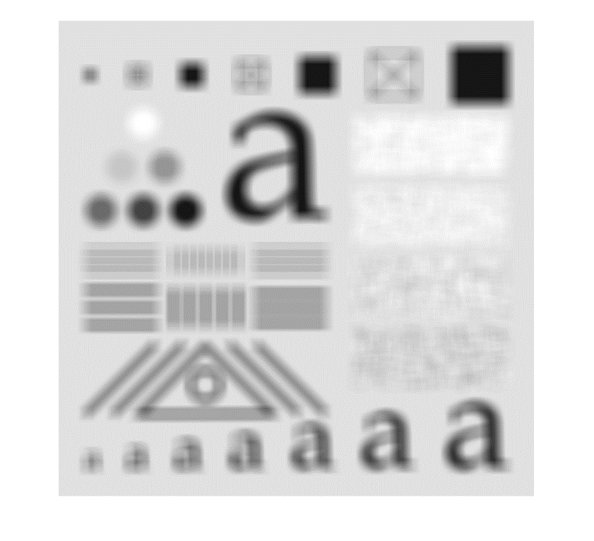

**6)** Image4:

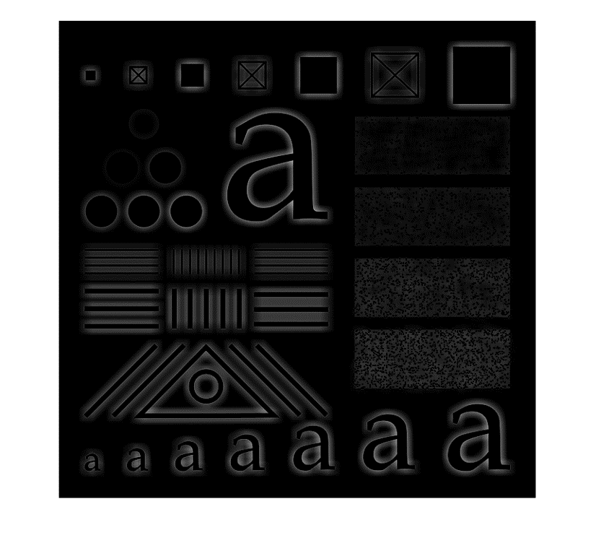

**7)** Why is so dark? What is the average value of the pixel values in ? And why?

% It is being clipped at 0 by the display causing it to contain negative

% values. This results to the black areas. This can be seen in the average % value => -1.5736e-15.

**8)** Image5:

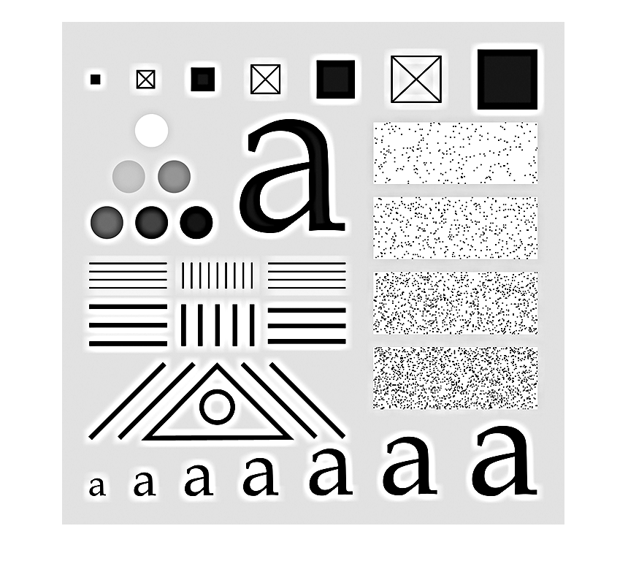

## **Testing Sobel filter kernels and gradient**

**9)** Image6:

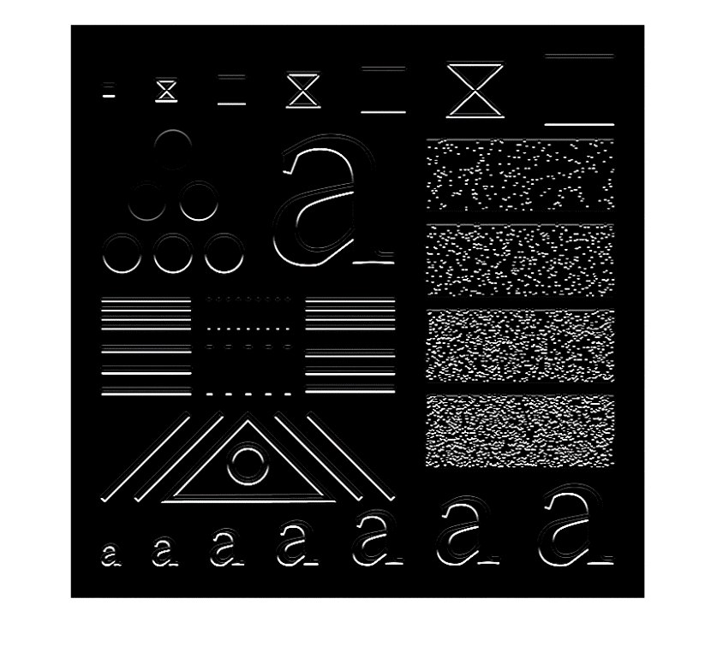

**10)** Image7:

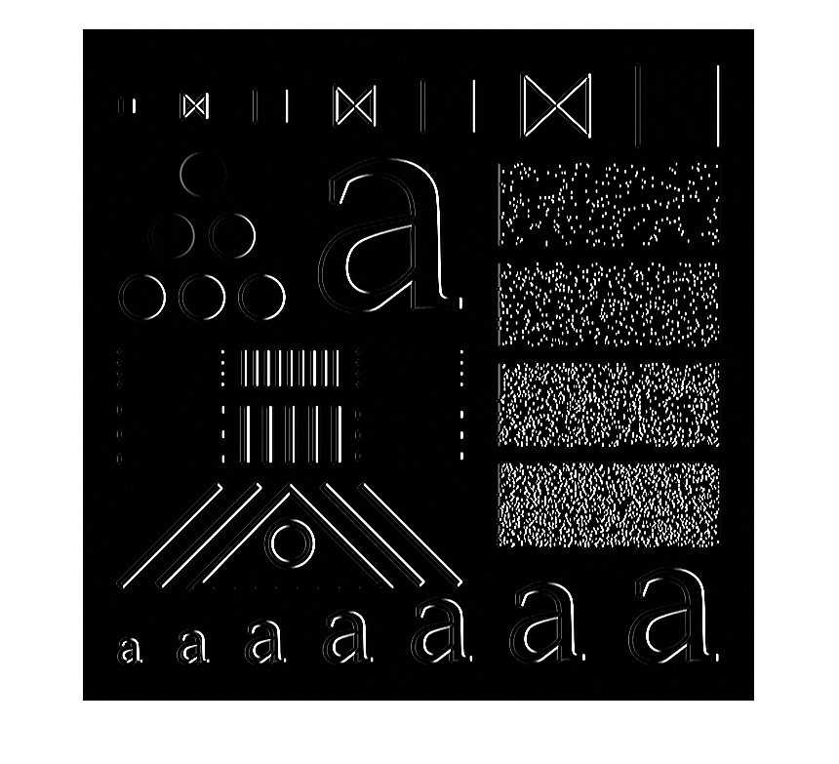

**11)** Image8:

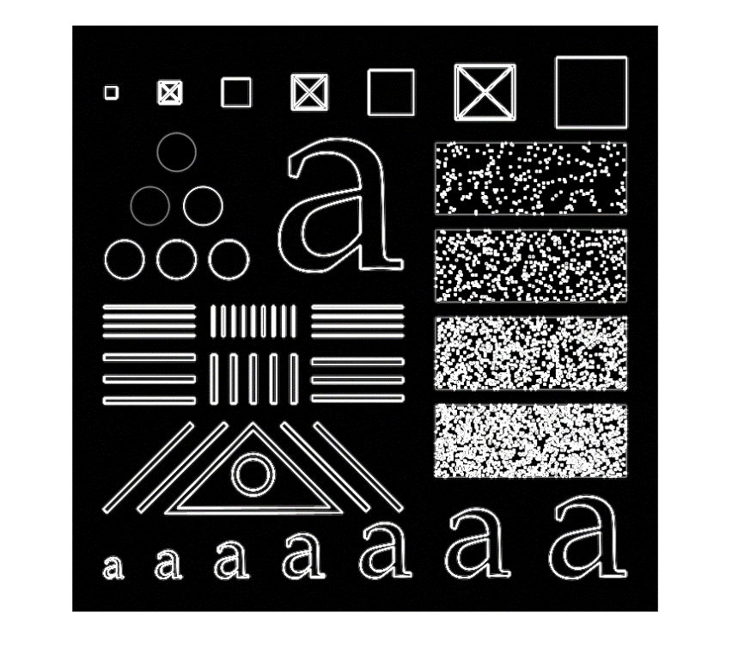

*Don’t forget to save the document as* ***.pdf*** *before submitting!*